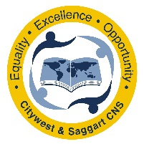
Pobalscoil Náisiúnta
Iarthar na Cathrach & Theach Sagard
Lána Bhaile Uí Fhoirtcheirn,
Iarthar Na Cathrach,
Baile Átha Cliath 24

Príomhoide: Maidhc O’ Broin
Leas-phríomhoide: Orla Uí Dochartaigh

Citywest & Saggart
Community National School
Fortunestown Lane,
Citywest
Dublin 24

Principal: Mike Byrne
Deputy Principal: Orla Doherty

Introduction

Introductory Statement
The creation of this Healthy Eating Policy should be seen in the context of promoting healthy eating habits in the school community. The relationship between good nutrition, children’s ability to learn and the prevention of illness is well established. Eating a nourishing breakfast and a healthy school lunch allows children to take full advantage of the education provided for them. The school, in consultation with parents, teachers and students plays an important role in promoting healthy eating habits among our pupils. This is achieved through our Social Personal Health Education Programme, Science lessons and through this Healthy Eating Policy.
This policy has been formulated by staff with parental input, and endorsed by the Board of Management. The parents were surveyed in February 2020. The children were consulted in January 2020. All these answers along with a teacher review of current practices has led to the formulation of this policy.
Summary of this Healthy Eating Policy
General | The Healthy Eating Policy aims to provide guidelines and key information enabling parents, guardians and children to make informed choices about what foods should be present in lunch boxes.
Research | By 2025, 241,000 children in Ireland will be overweight or obese.  Increased sugar levels can impact concentration levels and quality of learning.
What can be done? | Early intervention – promote healthy eating  Eliminate foods with high levels of sugar in lunches  Introduce a wide variety of fruit and vegetables
N.B | Nuts and products containing nuts are not allowed due to severe allergies
Children | Important for the children to understand the reasons for and importance of healthy eating.
Lunch Ideas | List of lunch ideas contained in the Appendix
Additional Support | The school is participating in the Food Dudes programme in February 2020 where the children will receive portions of fruit and vegetables for a trial period.

Rationale:
Lunch is an important meal for children. It should provide one third of their recommended daily allowance of nutrients without being high in fat, salt or sugar. As part of the Social, Personal and Health Education (S.P.H.E) Programme, we also encourage the children to become more aware of the need for healthy food in their lunch boxes and to understand the need for the need for a healthy eating policy.

Aims:
This aims of this policy are to:
- Provide examples of the foods that are recommended;
- Promote the personal development and well-being of the child;
- Promote the health of the child and provide a foundation for healthy living;
- To encourage children to eat sensibly so that they can derive maximum benefit from the teaching and learning opportunities provided in the course of the school day.

Objectives:
- To enable the child to appreciate the importance of good nutrition for growing and staying healthy.
- To enable the child to understand the reasons for making wise food choices and adopting a healthy, balanced diet.
- To enable parents and guardians to make informed choices in helping their children to eat healthily at school.

Research has shown that poor concentration and hyperactivity in children can be caused by nutritional imbalances. Imbalances in blood sugar levels, caused by eating sweet foods also impairs learning and concentration. Research by the World Obesity Federation predicts that by 2025, 241,000 schoolchildren in Ireland will be overweight or obese by 2025. The study recommends early interventions highlighting the need for our healthy eating policy.

The Food Pyramid:
The food pyramid is designed to provide a guideline for healthy eating. Foods that contain a similar amount of nutrients are placed together on the same shelf. Using the food pyramid as a guide for healthy eating will ensure that a balance of nutrients is consumed.

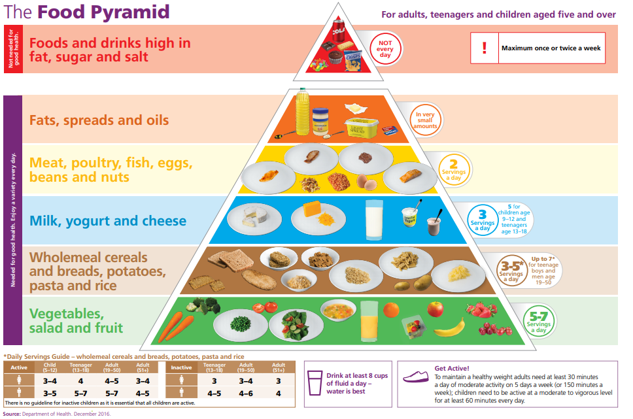
- It is very important for children’s energy and concentration levels that they eat a healthy breakfast before coming to school.
- A healthy lunchbox includes pieces from each of the first four shelves of the food pyramid.
- Bottom shelf carbohydrates (energy), fruit, and vegetables (vitamin/minerals rich) are especially encouraged to ensure recommended daily portions are met.
- Children will have two food breaks during the day and are given 10 minutes at each break to eat their lunch.
- Children will take home any rubbish thereby enabling parents to review how much lunch the children are eating.
- Any food from the top shelf of the pyramid is not allowed in school. Due to severe allergies, nuts or products containing nuts are also not permitted.
- Staff will support the healthy eating policy and will not offer sweets to children as rewards or prizes.
- Cakes, buns or treats (sweets or chocolate) for birthdays will not be distributed.
Resources:
www.safefood.eu
www.healthpromotion.ie/health/healthy_eating
www.enjoyhealthyeating.info/
http://www.netmums.com/family-food/food-for-kids/lunchbox-ideas

Foods and drinks not allowed in school:

- NUTS and FOODS CONTAINING NUTS are strictly forbidden in Citywest & Saggart CNS as we have children that have serious allergies to them.
- Fizzy drinks/sweetened fruit juices
- Hot drinks such as tea, soup etc
- Sweets
- Crisps
- Chocolate bars/biscuits
- Any chocolate flavoured items
- Cereal bars
- Fast food
- Chewing gum is strictly forbidden
- Popcorn is considered a treat and is therefore not permitted as an everyday lunchbox item

If a child comes to school with an item that is not allowed in school, he/she will not be allowed to eat this item. A note will be sent home as a reminder to adhere to our healthy eating policy.

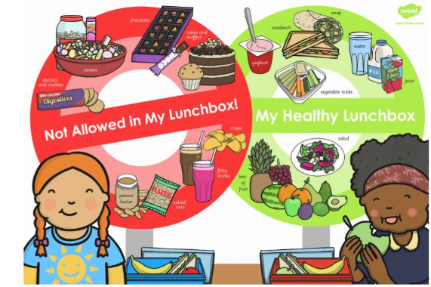
Dear Parent/Guardian,
We have a healthy eating policy in our school. (Insert item) is not suitable for a school lunch as it is high in sugar.
Please see our healthy eating policy for some alternative suggestions and ideas.

Is my Drink Tooth Friendly?
The following is a guide on the best drinks to give your children and when to ensure healthy teeth:
Any Time |  | Only At Mealtimes |  | Not Tooth Friendly
Water  Milk |  | Unsweetened fruit juice  Diluted sugar-free squash  Flavoured milk  Yoghurt or milk drinks  smoothies |  | Sweetened Fruit juice  Fizzy drinks(including diet versions)
Growing children should get approximately one pint of milk a day, or its equivalent as cheese, yoghurt or other dairy products. This ensures that they get enough calcium, which is essential for healthy bones and teeth. If your child does not drink milk at lunchtime, please encourage him/her to have a carton of yoghurt or a small helping of cheese instead.

Review and Evaluation:
The success of this policy will be judged on:
- The children bringing healthy lunches to school.
- The children becoming aware of healthy/unhealthy foods and drinks.
- The frequency of notes being sent home as a result of unhealthy food present in a lunch box.
- This policy was ratified by Board of Management in January 2020.
- This policy will be reviewed in January 2022.

Signed: 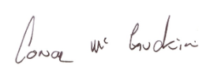 (Chairperson)  Date: 28.2.20 | Signed: 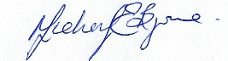 (Principal)  Date: 28.2.20

Appendix

Sample Lunch Ideas

The following guide is designed to help provide quick, appetising and nutritious lunches for children. They are suggestions and the list is by no means exhaustive. If any parent has any good ideas they would like to share, we are always willing to take new ideas on board.
Sample 5 day lunchbox planner from Safefood– Healthy Lunchboxes

Below is a list of possible foods you could pack for your child’s lunch. This list is not exhaustive and only mentions samples of appropriate foods for the lunchbox.

Bread and Alternatives: | Fruit and Vegetables:
- Bread or rolls (preferably wholemeal)  - Pitta bread  - Wraps  - Crackers  - Rice Salad  - Pasta Salad  - Wholemeal scones  - Rice cakes (no chocolate) | - Apples, banana, peach  - Mandarins, oranges  - Carrot sticks  - Cucumbers  - Melon slices  - Pineapple cubes  - Grapes  - Sweetcorn  - Tomato
Savouries: | Drinks:
- Lean meat  - Chicken/ Turkey  - Tinned fish – tuna etc.  - Cheese  - Quiche  - Olives | - Milk  - Water  - Fruit juices (un-sweetened)  - Diluted sugar free squash  - Yoghurt drinks

Other Tips and Hints:
- Keep lunches in fridge if prepared the night before.
- Use a small insulated cool bag, especially in warmer weather.
- Cut sandwiches into small manageable pieces, especially for infants.
- Peel fruit for younger children.
- Avoid foods that children cannot eat without help.
- Make lunches as varied as possible. Children love comparing their lunches and talking about them so please make sure your child is excited about their lunch.
- Vary the types of bread in sandwiches (wholemeal, granary, high fibre rolls, bagels, pitta and sliced bread).
- If sending your child to school with a yoghurt, include a plastic bag to keep the empty packaging in.
- Encourage your child to bring their rubbish home in their lunchbox as this will inform you of what they have eaten.

